PlagiaScan: An Explainable Multi-Algorithm Plagiarism & Document Similarity Analyzer
A Project Based Learning Report Submitted in partial fulfilment of the requirements for the award of the degree

of

Bachelor of Technology
in The Department of Computer Science
DATA STRUCTURES AND ALGORITHMS 25CS2103E

Submitted by
Roll.no: 2510030372
Roll.no: 2510030403
Roll.no: 2510030225
Roll.no: 2510030158

Under the guidance of
Aftab Yaseen


Department of Computer Science Engineering
Koneru Lakshmaiah Education Foundation, Aziz Nagar
Aziz Nagar – 500075
FEB - 2025.
Abstract

Plagiarism is a widespread phenomenon, especially in academic and digital environments. It can be manifested in the form of direct copying, partial copying, shuffling of phrases or words, and paraphrasing. The detection of similarities between texts is not always an obvious task when comparing two texts using a single algorithm. To solve this problem, an explainable multi-algorithm plagiarism and document similarity analyzer called PlagiaScan was created.
PlagiaScan allows for the simultaneous comparison of multiple documents and uses various similarity detection algorithms. Initially, the Word Overlap algorithm determines the percentage of common text in the compared documents. Then, using the KMP and Rabin-Karp algorithms, words and phrases are extracted to find matching fragments. Token Edit Distance is used to detect differences in texts due to tokens’ insertions, deletions, and substitutions. Finally, the all-MiniLM-L6-v2 model with cosine similarity allows finding semantically similar phrases and sentences through paraphrasing.
The results of these similarity techniques are combined using a weighted scoring approach to calculate the overall plagiarism similarity value. One of the main features of the developed system is the provision of evidence for detected similarities, which provides transparency and explainability. This is accomplished by displaying the found similar phrases, statistics for each algorithm, comparisons, and rankings of documents. The user can thus see why similarities were detected in one section and what results the algorithms gave in another.
The front end of the application was implemented in React + Vite; the back end was implemented in Java 21 + Javalin REST. Semantic analysis was performed using DJL and Hugging Face with the all-MiniLM-L6-v2 model. In general, the described prototype allows for document comparison and plagiarism detection with algorithm transparency.

List of Figures

Figure 1. PlagiaScan System Architecture
Figure 2. Multi-Algorithm Plagiarism Detection Workflow
Figure 3. PlagiaScan Pairwise Document Comparison Results Showing Similarity Metrics and Matched Phrases

List of Tables

Table 1. Algorithms and Their Roles in PlagiaScan
Table 2. Similarity Metrics and Scoring Weights
Table 3. Test Documents Used for Prototype Evaluation
Table 4. Pairwise Similarity Results
Table of Contents
Abstract .................................................. i
List of Figures ......................................... ii
List of Tables .......................................... iii
- 1. INTRODUCTION ........................................ 1
- 2. METHODOLOGY ......................................... 2
2.1 System Architecture
2.2 Document Preprocessing
2.3 Word Overlap Similarity
2.4 KMP Pattern Matching
2.5 Rabin-Karp Pattern Matching
2.6 Token Edit Distance
2.7 Semantic Similarity using MiniLM
2.8 Weighted Similarity Scoring
2.9 Explainable Evidence Generation
- 3. EXPERIMENTS ........................................... 6
3.1 Experimental Setup
3.2 Test Documents
3.3 Pairwise Document Comparison
3.4 Identical Document Sanity Check
3.5 Prototype Testing
- 4. RESULTS ................................................ 8
4.1 Similarity Results
4.2 Analysis of Individual Similarity Metrics
4.3 Analysis of Pairwise Comparison Results
4.4 Explainable Similarity Evidence
4.5 Overall Results
- 5. CONCLUSION AND FUTURE WORK ................ 10
5.1 Conclusion
5.2 Future Work
5.3 Future Scope
- REFERENCES .............................................. 11

PlagiaScan: An Explainable Multi-Algorithm Plagiarism & Document Similarity Analyzer
1 Introduction
Plagiarism is a major concern for online and academic spaces, where similar content can appear in multiple sources in various ways. Such copies can range from near-verbatim excerpts to paraphrased versions, utilizing only specific parts of the original text, changed words, or shuffled sentence structures. As the number of digital documents grows exponentially, evaluating a set of papers for potential plagiarism manually is challenging and time-consuming. Existing tools for plagiarism detection tend to summarize the comparison as a single percentage, which does not explain the details of the similarities between the documents. PlagiaScan is an explainable document similarity and plagiarism analysis system, built to handle multiple comparisons at once. The tool is designed to report multiple pieces of evidence for the detected similarities between documents rather than a monolithic percentage. PlagiaScan: Explainable Multi-Algorithm Plagiarism and Document Similarity Analyzer is a system that can process multiple sets of documents and utilize various algorithms to detect similarities and instances of plagiarism. The system implements Word Overlap, which evaluates the amount of shared vocabulary between compared documents. It also employs Knuth-Morris-Pratt and Rabin-Karp algorithms to find repeated phrases in the set of documents. PlagiaScan utilizes Token-level Edit Distance to assess the differences between the compared texts. Finally, the system uses all-MiniLM-L6-v2 and cosine similarity to find semantically similar sentences and documents. The system first preprocesses the uploaded documents to simplify the comparison and standardize the data. It transforms all characters to lower-case, removes punctuation and extra whitespace, and tokenizes the texts. The system subsequently uses Word Overlap, exact matching, and edit distance algorithms to find overlapping words, repeated fragments, and similar words with different stems, respectively. Meanwhile, the semantic similarity engine processes the texts, representing their numeric embeddings with MiniLM and calculating their cosine similarity. The outputs of all algorithms are combined into a single set of results. Similarity between the compared fragments of texts is assessed in percentages using the Textual Similarity metric, which combines Word Overlap, Edit Similarity, and Exact Match Coverage. Finally, the scores are combined with Semantic Similarity to produce the ultimate output. PlagiaScan focuses on providing an explainable interface, which details not only the final similarity score, but also provides multiple metrics, describing textual similarities between the compared documents. In particular, the system allows the users to review Word Overlap, Edit Similarity, Exact Match Coverage, Textual Similarity, and Semantic Similarity scores for each of the compared pair of documents. Moreover, the implementation of KMP and Rabin-Karp allows highlighting the matching phrases detected in the compared texts. The system is designed to handle multiple comparisons at once, allowing the user to upload an array of documents and define similarities between all possible pairs. PlagiaScan outputs the similarity scores and ranking for each pair, along with the matrix of scores to facilitate the plagiarism research. Explainable similarity detection engines offer a major advantage in providing detailed evidence for the similarity between the compared documents. In particular, multiple algorithms allow analyzing different types of similarities, which a single approach, such as comparing entire documents for overlaps, may miss. Copying can be achieved through verbatim excerpts, which will be detected by exact match algorithms, and paraphrased sentences, which may involve some editing and would require edit-distance or semantic analysis to identify. Using multiple approaches to similarity detection benefits the user, who can benefit from the granular insight into the similarities between the compared texts. Word Overlap, KMP, Rabin-Karp, and Edit Distance algorithms offer different ways to define similarities between two texts. They can be applied either to individual words, such as finding similar words with different stems with the Edit Distance algorithm, or entire sentences, as in detecting exact matches with KMP and Rabin-Karp algorithms. Combined with the semantic similarity detection using MiniLM embeddings, the system would highlight various ways in which two documents may overlap, providing extensive grounds for suspicion of plagiarism. The combination of multiple approaches is particularly beneficial when applied to multiple documents, where one would need to assess all comparisons individually and review the matrix of similarities between them. PlagiaScan is implemented as a web system, with React and Vite as the frontend framework and Java 21 and Javalin REST API as the backend. Semantic analysis is achieved through DJL, Hugging Face and all-MiniLM-L6-v2 model, while the rest of the algorithms are implemented in Java. The system follows decoupled architecture, separating the document uploading, analysis, semantic processing, and results visualization, facilitating future improvements and modifications. The project focuses on developing a multi-document plagiarism detection system, which utilizes multiple algorithms to find various similarities between the compared texts. It offers users an explainable interface, which highlights the similarities between the compared texts and documents, offering grounds for further manual investigation. PlagiaScan aims to facilitate text similarity detection in various fields, benefiting students, faculty, universities, researchers, content creators, and the online education industry in improving academic integrity.

2. METHODOLOGY

2.1 System Architecture
PlagiaScan uses a client-server architecture with React + Vite on the frontend, Javalin for the REST API, and Java 21 on the backend. The frontend handles document uploads, results, reports, rankings, and comparison history, while uploaded documents are sent to /analyze via POST. The Java analysis engine performs similarity calculations and uses Deep Java Library, Hugging Face, and the all-MiniLM-L6-v2 model for semantic analysis, with results displayed on the frontend.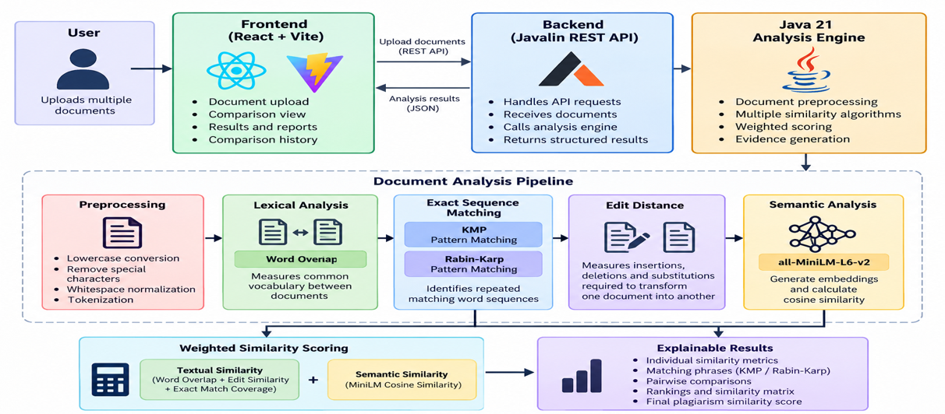
Figure. 1. PlagiaScan System Architecture

2.2 Document Preprocessing
Document preprocessing is the first step in the methodology. Each uploaded document is represented as a document object containing its name and text.
To make the documents suitable for comparison, the text is first converted into lowercase. Unnecessary characters are removed and extra spaces are normalized. The processed text is then divided into individual tokens. This creates a consistent representation of the documents that can be used by the different comparison algorithms.

2.3 Word Overlap Similarity
Word Overlap is used to measure how much vocabulary is shared between two documents. The unique words from both documents are compared, and their common words are used to calculate the similarity.
The implemented formula is:
Word Overlap = (|A ∩ B| / max(|A|, |B|)) × 100
This provides a basic lexical similarity score and contributes to the overall Textual Similarity value.

2.4 Knuth-Morris-Pratt Pattern Matching
The Knuth-Morris-Pratt (KMP) algorithm is used to identify repeated and exact word sequences between documents. It efficiently searches for a sequence of tokens within another sequence.
In PlagiaScan, KMP is mainly useful for providing evidence of exact matching phrases. It records the phrases that match and their positions in the documents. This allows the user to see where similar or repeated content appears.

2.5 Rabin-Karp Pattern Matching
Rabin-Karp is another pattern-matching algorithm used to identify matching sequences between documents. Instead of directly comparing every sequence, it uses hashing to find possible matches efficiently. When matching token sequences are identified, PlagiaScan records them as evidence. Using Rabin-Karp together with KMP provides another method for identifying repeated textual patterns.

2.6 Token Edit Distance
Token-level Edit Distance measures the minimum number of insertions, deletions, and substitutions required to transform the token sequence of one document into another. This method is useful when content has been modified rather than copied exactly. For example, a document may contain additional words, missing words, or replaced words while still being based on another document.
The implemented Edit Similarity formula is:
Edit Similarity = max(0, (1 − d/L) × 100)
Here, d represents the token-level edit distance and L represents the maximum token length of the two documents. Therefore, a smaller edit distance results in a higher edit similarity.
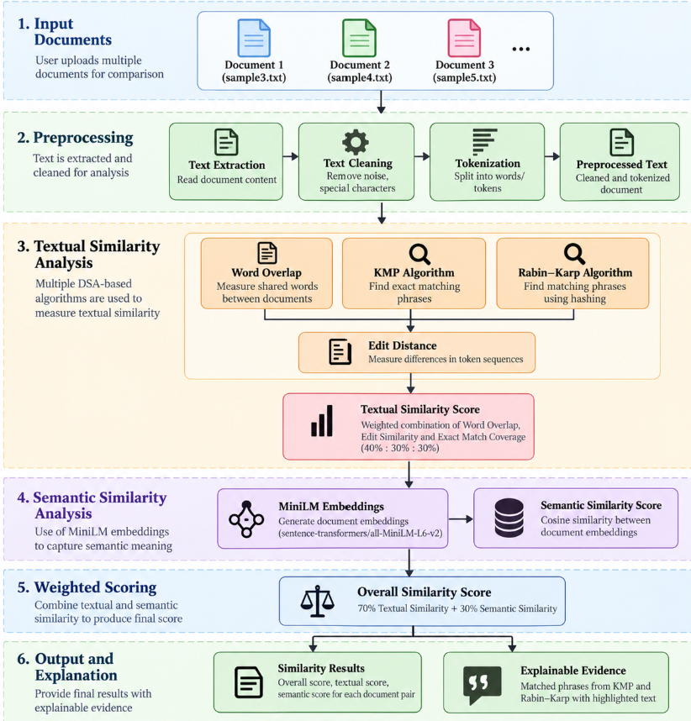
Figure 2. Multi-Algorithm Plagiarism Detection Workflow

2.7 Semantic Similarity using MiniLM
To detect similarity beyond exact wording, PlagiaScan uses the all-MiniLM-L6-v2 sentence-transformer model. The model converts the document text into numerical embeddings that represent the semantic information contained in the text. Cosine similarity is then calculated between the embeddings to determine their meaning-level similarity. This allows the system to identify similarities between documents that may use different words or sentence structures while expressing similar content.
Table 1. Algorithms and Their Roles in PlagiaScan
Algorithm | Purpose
Word Overlap | Measures common vocabulary between documents
KMP | Detects repeated exact word sequences
Rabin-Karp | Detects matching token sequences using hashing
Token Edit Distance | Detects insertions, deletions and substitutions
MiniLM + Cosine Similarity | Detects meaning-level and paraphrased similarity

2.8 Weighted Similarity Scoring
The individual textual measures are combined to produce a Textual Similarity score:
Textual Similarity = 0.40 × Word Overlap + 0.30 × Edit Similarity + 0.30 × Exact Match Coverage
The textual score is then combined with semantic similarity:
Final Similarity = 0.70 × Textual Similarity + 0.30 × Semantic Similarity
This weighted approach allows PlagiaScan to combine lexical, exact, structural, and semantic signals into one overall plagiarism similarity score while retaining the individual metrics for explanation.
Table 2. Similarity Metrics and Scoring Weights
Metric | Weight
Word Overlap | 40% of Textual Similarity
Edit Similarity | 30% of Textual Similarity
Exact Match Coverage | 30% of Textual Similarity
Textual Similarity | 70% of Final Similarity
Semantic Similarity | 30% of Final Similarity

2.9 Explainable Evidence Generation

The last stage of methodology is the generation of an explainable comparison report. For each pair of documents, PlagiaScan provides the comparison of individual similarity metrics, overall similarity score, evidence of matching using KMP and Rabin-Karp algorithms, and semantic interpretation. In addition, for multiple documents, the pairwise comparisons, ranking, and similar matrix are generated. Therefore, the system does not only show how similar two documents are. It also provides information about why the documents were considered similar.

3. EXPERIMENTS
3.1 Experimental Setup
The PlagiaScan prototype was developed as a web-based document similarity analysis system. React and Vite were used to develop the frontend, while Java 21 and the Javalin REST API were used for the backend. The document analysis engine combines several similarity techniques, including Word Overlap, Knuth-Morris-Pratt (KMP), Rabin-Karp, Token Edit Distance, and semantic similarity using the all-MiniLM-L6-v2 model. The prototype accepts multiple documents and performs pairwise comparisons between them. The experiments were carried out to check whether the individual similarity measures, weighted scoring method, and explainable evidence generation were working correctly. Identical documents were also tested to verify whether all similarity measures produced a complete similarity result.
3.2 Test Documents
For prototype testing, sample text documents were uploaded into PlagiaScan and compared pairwise. The system generates a comparison result for every possible document pair and displays the individual similarity measures along with the overall similarity score.
The prototype results presented in the project demonstration included comparisons between sample3.txt, sample4.txt, and sample5.txt. These documents were used to demonstrate both highly similar and comparatively less similar document pairs.

Table 3. Test Documents Used for Prototype Evaluation
Document | Purpose
sample3.txt | Prototype comparison document
sample4.txt | Prototype comparison document
sample5.txt | Prototype comparison document

3.3 Pairwise Document Comparison
When multiple documents are uploaded, PlagiaScan performs pairwise comparison between the documents. Each pair is evaluated using Word Overlap, Edit Similarity, Exact Match Coverage, Textual Similarity, and Semantic Similarity. KMP and Rabin-Karp additionally provide matching phrase evidence.
For the demonstrated prototype, sample4.txt and sample5.txt produced an overall similarity of 100.00%, with both textual and semantic similarity also reaching 100.00%. The comparison between sample4.txt and sample3.txt produced a textual similarity of 11.42%, semantic similarity of 70.13%, and an overall similarity of 29.03%. The same overall result was obtained for sample5.txt and sample3.txt.
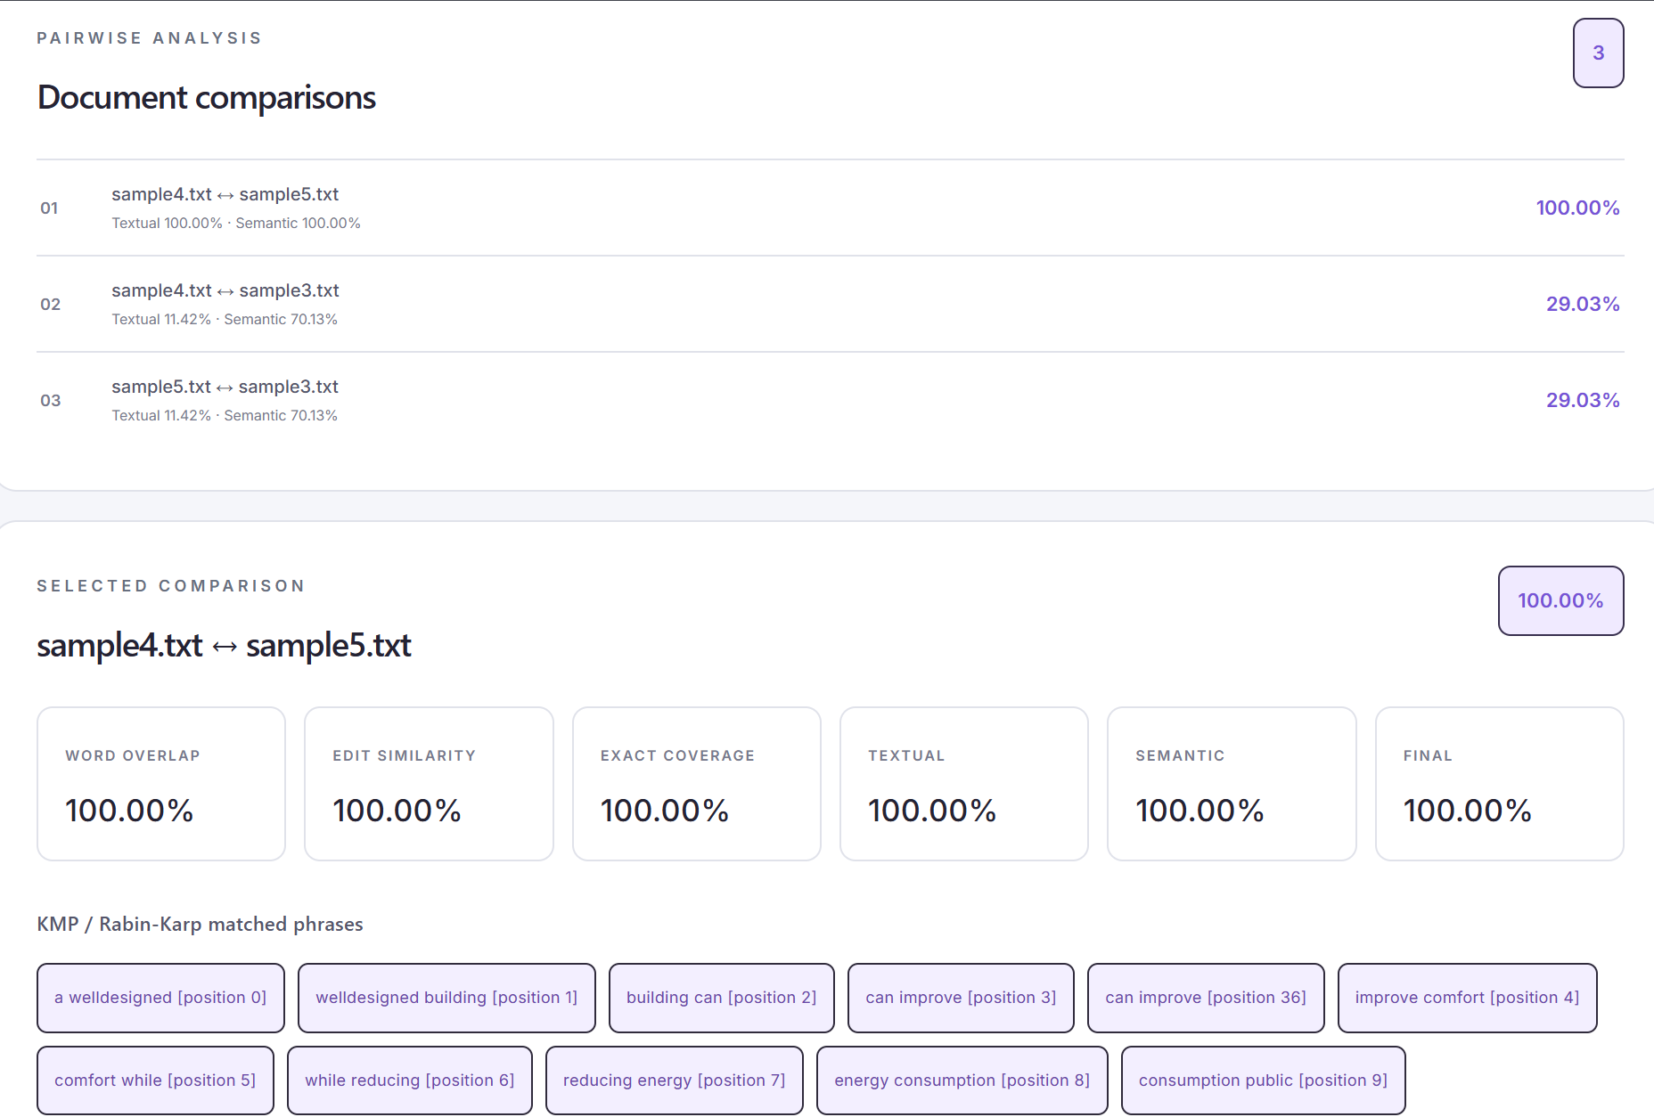
Figure 3. PlagiaScan Pairwise Document Comparison Results Showing Similarity Metrics and Matched Phrases
3.4 Identical Document Sanity Check
An identical-document test was performed as a basic sanity check for the implemented similarity pipeline. When identical documents were compared, the system produced 100% for Word Overlap, Edit Similarity, Exact Coverage, Textual Similarity, Semantic Similarity, and Final Similarity. This confirms that the implemented scoring components converge correctly when the input documents are identical.
3.5 Prototype Testing
The prototype was also evaluated based on the evidence produced alongside the similarity scores. The system successfully displayed individual similarity metrics and matching phrases identified through KMP and Rabin-Karp. It also provided pairwise rankings and comparison results for multiple uploaded documents. These tests demonstrate the intended explainable nature of the system, where the final plagiarism similarity score is accompanied by the underlying similarity measures and matching evidence.
The experiments therefore demonstrate that the implemented PlagiaScan prototype can perform multi-document pairwise comparison, combine multiple similarity signals, detect exact and semantic similarity, and present explainable evidence through the user interface.

4. RESULTS

4.1 Similarity Results
The PlagiaScan prototype was evaluated by comparing three sample documents using the combined textual and semantic similarity approach. The results obtained from the system are presented in Table 4.

Table 4. Similarity Results for Sample Document Pairs
Document Pair | Textual Similarity | Semantic Similarity | Overall Similarity
sample4.txt ↔ sample5.txt | 100.00% | 100.00% | 100.00%
sample4.txt ↔ sample3.txt | 11.42% | 70.13% | 29.03%
sample5.txt ↔ sample3.txt | 11.42% | 70.13% | 29.03%
The results show that sample4.txt and sample5.txt, which contain identical content, achieved 100.00% textual similarity, 100.00% semantic similarity, and 100.00% overall similarity. In comparison, sample4.txt and sample3.txt, as well as sample5.txt and sample3.txt, produced an overall similarity of 29.03%. Although these pairs had a relatively low textual similarity of 11.42%, their semantic similarity was 70.13%, indicating that the documents contained some semantically related content despite having limited direct textual overlap. This demonstrates how PlagiaScan combines exact textual matching with semantic similarity to provide a more comprehensive measure of document similarity.

4.2 Analysis of Individual Similarity Metrics
PlagiaScan uses several algorithms to assess document similarity. The Word Overlap algorithm compares two texts by scanning the number of common words, while the KMP and Rabin-Karp algorithms search for identical phrases. Meanwhile, the Edit Distance algorithm determines the difference between text tokens, and MiniLM calculates semantic similarity based on the meaning of the text. Using these algorithms, one can estimate document similarity either via textual similarity or semantic similarity. The former is determined as a weighted combination of Word Overlap, Edit Similarity, and Exact Match Coverage, with weights of 40%, 30%, and 30%, respectively. The overall similarity score is then determined by combining textual and semantic similarities with weights of 70% and 30%, respectively.
It should be noted that a combination of algorithms allows for detecting both exact matches and semantically similar portions of text. Additionally, the individual similarity scores, along with matched phrases, are provided to users, allowing them to understand how the overall similarity score was calculated. Based on the calculations, it can be concluded that textual and semantic similarities are different. For instance, in the case of the sample4.txt and sample5.txt documents, both similarities are equal to 100%. However, when comparing sample3.txt with sample4.txt and sample5.txt, textual similarity was only 11.42%, while semantic similarity was 70.13%. Thus, it can be said that multiple similarity scores allow for better evaluation of similarities between documents.

4.3 Analysis of Pairwise Comparison Results
The results of pairwise comparisons reflect how PlagiaScan treats documents, which have direct copy-paste parts, and documents, which only share some ideas.
The sample4.txt and sample5.txt comparison resulted in an overall similarity of 100%. The textual and semantic similarities of the documents equal, which means that the documents are identical. This result indicates that the documents have complete textual and semantic similarity and would warrant further investigation for potential plagiarism. The comparison of sample3.txt with others resulted in a 29.03% overall similarity. The textual similarity was only 11.42%, but semantic similarity scored quite high at 70.13%. It proves that some concepts of the documents resemble each other, but they do not share many text fragments. The documents are not similar, but some ideas expressed in them coincide.
Therefore, pairwise comparison results show how the plagiarism system treats text and semantic similarity. The documents, which were compared, only partially match but share significant ideas. On the other hand, sample5.txt and sample4.txt are identical, so the similarity score is 100%. A document with minor similarities could be mistakenly flagged as highly similar if not for the semantic analysis. PlagiaScan allows the user to choose papers with both high conceptual and textual similarities.

4.4 Explainable Similarity Evidence
In addition to the similarity score, PlagiaScan offers evidence supporting the score. The KMP and Rabin-Karp algorithms find matching phrases, while individual similarity scores explain how much text the documents share.
Using these explainable results, the user gets a better look at the similarities and can understand why two documents got a specific score. Instead of having a single score, the user gets a similarity score, semantic similarity score, matched-phrase evidence, and comparison of contents for the two documents.
Doing this improves the usability of the plagiarism checker because it enables the user to differentiate between two text sources that share a large part of the text and two texts that are similar semantically but do not share any text. The explainability feature is particularly useful for checking similarities between academic documents because it allows the user to see the evidence instead of relying solely on a number provided by an automated system.

4.5 Overall Results
The prototype evaluation demonstrates that PlagiaScan can combine multiple document similarity techniques into a single analysis workflow. The system successfully performs word-level comparison, phrase matching using KMP and Rabin–Karp, token-level comparison using Edit Distance, and semantic comparison using MiniLM embeddings.
The experimental results show that identical documents can be detected with an overall similarity score of 100.00%. For the other tested document pairs, the system produced a lower textual similarity of 11.42% while detecting a higher semantic similarity of 70.13%. Their final overall similarity score was 29.03%.
The weighted scoring mechanism combines these different forms of evidence into a single overall similarity score. At the same time, the individual metrics and matched phrases provide additional information that helps explain the result.
Overall, the results demonstrate the functionality of the PlagiaScan prototype as a multi-algorithm and explainable document similarity analysis system. The prototype shows that combining traditional string and text comparison algorithms with semantic similarity can provide a broader analysis of document relationships than relying on a single algorithm.

5. CONCLUSION and FUTURE WORK

5.1 Conclusion
PlagiaScan was conceived as an explainable multi-algorithm document similarity analysis framework. The tool integrates conventional text comparison algorithms and approaches the task from a semantic perspective, identifying various types of similarities between documents.
The comparison is performed using Word Overlap, KMP, Rabin-Karp, Edit Distance, and MiniLM algorithms, each of which is used to identify different types of similarities between the texts being compared.
While conventional text-based comparison algorithms were used to identify overlaps in word occurrences, semantic similarity was used to find connections between texts with dissimilar wording.
The weighted scoring strategy allowed the final similarity score to be determined based on the combined consideration of multiple factors. As shown by the test results, the prototype correctly identified completely identical documents with a similarity score of 100.00%, while other document pairs exhibited a lower, varying depending on the text similarity score.
In addition, one of the most notable advantages of the PlagiaScan prototype is explainability – instead of showing a single final score, the tool displays several scores that characterize different aspects of text similarity. Moreover, the matching phrases can also be displayed, which allows the user to better understand why two texts are similar.
Thus, the project has demonstrated the feasibility of combining multiple DSA-based algorithms and approaches to semantic analysis to create an effective and explainable document similarity analysis tool.

5.2 Limitations
The current PlagiaScan prototype has some limitations. The assessment was conducted on a limited set of sample documents, and thus it cannot be extrapolated to large-scale document collections.
The system focuses primarily on textual similarity, meaning that documents with complex layouts, graphics, scans, or other non-text elements may need additional processing before being analyzed for plagiarism.
The semantic similarity component depends heavily on the quality of representation learned by the MiniLM embedding model. As such, semantic similarity should be interpreted as a similarity score between document representations rather than a direct probability of plagiarism.
Finally, the current assessment does not make use of a large labelled corpus of known plagiarized and non-plagiarized documents. As such, it is currently not possible to report precision, recall, and F1 scores for the prototype.

5.3 Future Scope
There are several ways in which PlagiaScan can be improved in the future.
The system can be expanded to include additional document formats such as word documents, spreadsheets, and presentations. This would make the system more useful for real-world document analysis.
OCR capabilities can also be added so that text can be extracted from scanned documents and images. Speech-to-text technology can also be used to extend the system to support audio and video content.
Future versions can be evaluated using large datasets to enable more systematic testing and benchmarking. This would make it possible to compute performance measures such as precision, recall, F1-score, and accuracy.
The user interface can also be improved by adding more detailed similarity visualization, document-level similarity matrices, historical comparisons reports, and interactive similarity highlighting of evidence.
In the long-term, PlagiaScan can also be turned into a scalable web-based plagiarism analysis platform that can be able to handle larger document collections while providing detailed and explainable similarity reports.

References
[1] I. Masic, “Plagiarism in scientific research and publications and how to prevent it,” Materia Socio-Medica, vol. 26, no. 2, pp. 141–146, 2014, doi: 10.5455/msm.2014.26.141-146.
[2] G. Helgesson and S. Eriksson, “Plagiarism in research,” Medicine, Health Care and Philosophy, vol. 18, no. 1, pp. 91–101, 2015, doi: 10.1007/s11019-014-9583-8.
[3] H. Arabi and M. Akbari, “Improving plagiarism detection in text document using hybrid weighted similarity,” Expert Systems with Applications, vol. 207, Art. no. 118034, 2022, doi: 10.1016/j.eswa.2022.118034.
[4] M. A. El-Rashidy, R. G. Mohamed, N. A. El-Fishawy, and M. A. Shouman, “An effective text plagiarism detection system based on feature selection and SVM techniques,” Multimedia Tools and Applications, vol. 83, pp. 2609–2646, 2024, doi: 10.1007/s11042-023-15703-4.
[5] M. Sajid, M. Sanaullah, M. Fuzail, T. S. Malik, and S. M. Shuhidan, “Comparative analysis of text-based plagiarism detection techniques,” PLOS ONE, vol. 20, no. 4, Art. no. e0319551, 2025, doi: 10.1371/journal.pone.0319551.

